

UCCD1203 DATABASE DEVELOPMENT AND APPLICATIONS

Assignment

June 2023

Group No:

|  |  |  |  |  |  |
| --- | --- | --- | --- | --- | --- |
| No | Student ID | Name | Program | Lecture Group | Signature |
| 1. | **2202026** | **Leong Sin Yu** | **IA** | **L3** | **leong** |
| 2. | **2106573** | **Leong Wei Feng** | **IA** | **L3** |  |
| 3. | **2301973** | **Richard Ting Li Zeng** | **IA** | **L3** | **Richard** |
| 4. | **2202415** | **Toh Weng Kee** | **IA** | **L3** | **toh** |

Marking Section:

|  |  |
| --- | --- |
| Section | Marks |
| Part A |  |
| Part B |  |
| TOTAL |  |

**MARKING SCHEME**

|  |  |
| --- | --- |
| **Scholarship Application Database Case Study** | |
| **Check list for Part A – Database Design (5%)** | |
| 1. **Introduction (5 marks)**  Describe the system overview, 3 main objectives of this project, and the list of database user. |  |
| 1. **ER model (15 marks)** You are required to design an ER diagram for the case study given, identify entities, identify relationships, identify associate attribute, and determine keys. Check the ERD with the requirements stated in the case. Resolve all the many-many relationships. |  |
| 1. **Business Rule** **Requirements (10 marks)**   Identify the business rule involve based on the ERD. Please include any assumptions that you make. |  |
| 1. **Report (5 marks)**   Submit your report with proper technical report writing skills (cover page, headers & footers, page numbering, headings, sections numbering, proper fonts, spell checked, proper alignments, spacing, marking scheme, table of contents etc). |  |
| **SUBTOTAL:** | **/35** |

|  |  |
| --- | --- |
| **Check list for Part B – The Implementation of Database using Microsoft Access (5%)** | |
| 1. **Tables and records (15 marks)**   Create all the relations in the ERD and insert the necessary records. (at least 10 records per table except for scholarship provider records) |  |
| 1. **Queries (15 marks)**   Create 3 useful queries based on the given case study and include the corresponding SQL command. Explain the purpose of each query. |  |
| 1. **Forms (15 marks)**   Create 3 useful forms based on the given case study. You may use subform(s). Explain the purpose of each form. Include colours/images to make your form look interesting. |  |
| 1. **Reports (15 marks)**   Create 3 useful reports based on the given case study. Explain the purpose of each report. Design your reports so that it will look proper and easy to understand. |  |
| 1. **Switchboard (5 marks)**   Create a switchboard that includes all the tables, forms, queries and reports. Make sure the switchboard can **start automatically** when the database is open and include the **exit button** to exclude the user from the database. |  |
| **SUBTOTAL:** | **/65** |

**TABLE OF CONTENTS**

|  |  |
| --- | --- |
| **FRONT PAGE** | **i** |
| **MARKING SCHEME** | **ii** |
| **TABLE OF CONTENTS** | **iv** |
| **LIST OF FIGURES** | **v** |
| **LIST OF TABLES** | **vi** |
|  |  |
| **CHAPTER 1 PROJECT BACKGROUND** | **1** |
| 1.1 System Overview |  |
| 1.2 Project Objectives |  |
| 1.3 Target Database User |  |
|  |  |
| **CHAPTER 2 DATABASE DESIGN** |  |
| 2.1 List of entities and attributes |  |
| 2.2 Entity Relationship Diagram (ERD) |  |
| 2.3 Assumptions and Business Rules |  |
|  |  |
| **CHAPTER 3 DATABASE DEVELOPMENT** |  |
| 3.1 List of tables |  |
| 3.1.1 Data Dictionary and Table Records |  |
| 3.2 Switchboard |  |
|  |  |
| **CHAPTER 4 DATABASE OBJECTS** |  |
| 4.1 Queries |  |
| 4.2 Forms |  |
| 4.1 Reports |  |
|  |  |
| **CHAPTER 5 CONCLUSION** |  |
| 5.1 System Weaknesses |  |
| 5.2 Future Improvement |  |

**LIST OF FIGURES**

|  |  |  |
| --- | --- | --- |
| **Figure Number** | **Title** | **Page** |
| Figure 1.1 | Entity Relationship Diagram (ERD) | 10 |
| Figure 1.2 | Data dictionary for student | 13 |
| Figure 1.3 | Table records for student | 14 |
| Figure 1.4 | Data dictionary for SPM result | 14 |
| Figure 1.5 | Table records for SPM result | 15 |
| Figure 1.6 | Data dictionary for submission | 15 |
| Figure 1.7 | Table records for submission | 15 |
| Figure 1.8 | Data dictionary for application | 16 |
| Figure 1.9 | Table records for application | 16 |
| Figure 2.0 | Data dictionary for recommendation | 16 |
| Figure 2.1 | Table records for recommendation | 17 |
| Figure 2.2 | Data dictionary for scholarship provider | 17 |
| Figure 2.3 | Table records for scholarship provider | 17 |
| Figure 2.4 | Switchboard (Main) | 18 |
| Figure 2.5 | Switchboard (Table) | 18 |
| Figure 2.6 | Switchboard (Query) | 19 |
| Figure 2.7 | Switchboard (Report) | 19 |
| Figure 2.8 | Switchboard (Form) | 19 |
| Figure 2.9 | Sample query 1 (Searching the Result for Malay Language, English Language, Mathematics, and History) | 20 |
| Figure 3.0 | Sample query 2 (Selection for the Science subjects) | 21 |
| Figure 3.1 | Sample query 3 (Checking the status of the application progress) | 21 |
| Figure 3.2 | Sample query 4 (Reference of the recommendation and reasons for being recommended) | 22 |
| Figure 3.3 | Sample query 5 (Additional Reference for the scholarship application) | 23 |
| Figure 3.4 | Sample form 1 (Students Information) | 23 |
| Figure 3.5 | Sample form 2 (SPM Results) | 24 |
| Figure 3.6 | Sample form 3 (Scholarship Provider) | 24 |
| Figure 3.7 | Sample form 4 (Recommendation Reference) | 25 |
| Figure 3.8 | Sample report for Information Reference | 25 |
| Figure 3.9 | Sample report for Referee Reference | 26 |
| Figure 4.0 | Sample report for Scholarship Application Progress | 26 |
| Figure 4.1 | Sample report for Recommendation Reason Summary | 27-28 |

**LIST OF TABLES**

|  |  |  |
| --- | --- | --- |
| **Table Number** | **Title** | **Page** |
| Table 1.1 | List of entities and attributes | 9 |

**Chapter 1: Project Background**

* 1. **System Overview**

In this work, we will create a database of scholarship applications that SPM graduates may use to apply. This database system will extract the SPM results based on five (5) significant disciplines, including any one of the science courses, English, Sejarah, Mathematics, and Bahasa Melayu. The tools will allow the student to see the application's status.

* 1. **Project Objectives**

Apparently, there are some disadvantages in the current paper-based processing.

The following are some of these issues:

1. Communication is inconvenient and time-consuming.

2. Consumption of paper and ink

3. Extensive workload

4. Difficulty in maintaining and searching data

This report's major aim is to develop and construct a database management system for the complete scholarship application organization. The specific objectives are as follows: To create a database that will be used to preserve information about applicants and scholarship givers. To manage the information of students who have applied for various scholarships. To assist providers in locating the specifics of qualified scholarships. To create an application that lowers the stress of seeking for a specific user's paper or book.

* 1. **Target database user**

1. Student
2. Recommender
3. Scholarship Provider
4. Guardian

**Chapter 2 : Database Design**

**2.1 List of entities and attributes**

|  |  |
| --- | --- |
| **Entity** | **Attributes** |
| Student | S_ID,S_ICNo,S_SchoolName,S_Name,S_PhoneNo,  S_H_Address,S_DOB,S_CorrespondenceLetter,  S_PersonalEmail,G_Name,G_Age,G_Occupation,  G_Gender,G_Relationship,SPMR_Code(FK),AppCode(FK) |
| SPM result | SPMR_Code (PK), Malay, Eng, Math, Add_Math, Sci, Phy, Chem, Bio, Add_Sci, His, S_ID (FK) |
| Submission | S_ID(PK,FK), AppCode(PK,FK), SubDate |
| Application | AppCode(PK), AppDate, Appextraactivity, Appcomactivity, AppStatus, RecommendCode(FK), ScholarshipID(FK), Remark |
| Recommendation | RecommendCode(PK), refID(FK), AppCode(FK), RecommendReason |
| Referee | refID(PK), refName, refRelationship, refOccupation, refAddress, RecommendCode(FK) |
| Scholarship Provider | ProviderID(PK), ProviderName, ProviderOrganisation, ScholarshipID, ScholarshipName |

|  |
| --- |
| Table 1.1 |

**2.2 Entity Relationship Diagram (ERD)**

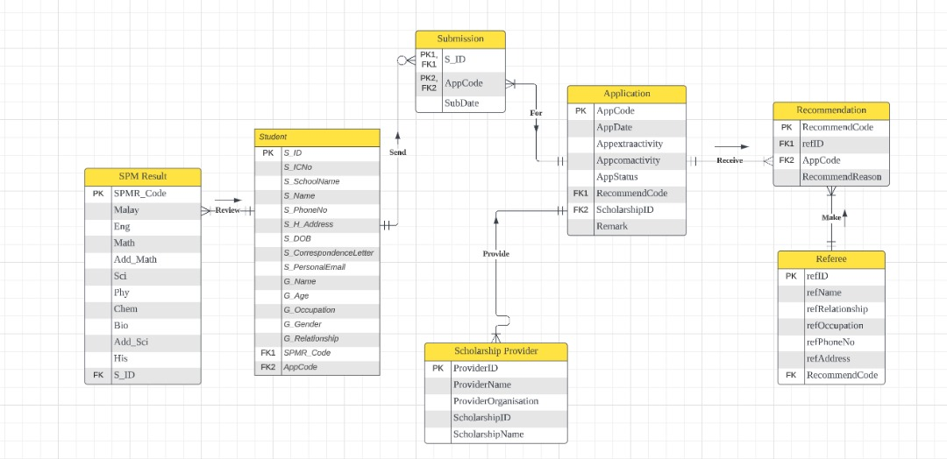

|  |
| --- |
| Figure 1.1 |

**2.3 Assumptions and Business Rules**

**Assumptions**

**Student:**

Assume that each student is review for one or many SPM results.

Assume that each student is send for zero or one or many submission.

**SPM result:**

Assume that each SPM result is only sent by one student.

**Submission:**

Assume that each submission is only sent by one student.

Assume that each submission is only for one application.

**Application:**

Assume that each application is received by one or many recommendations.

Assume that each application is for one or many by the submission.

Assume that each application is provided one or many by the scholarship provider.

**Recommendation:**

Assume that each recommendation is only receive for one application.

Assume that each recommendation is only made by one referee.

**Referee:**

Assume that each referee is made for one or many recommendation.

**Scholarship Providers:**

Assume that each scholarship provider can be provided with one or more applications.

**Business Rules**

**Student:**

One student reviews one or many SPM results.

One student sends zero or one or many submission.

**SPM result:**

One SPM result only sent by one student.

**Submission:**

One submission only sent by one student.

One submission only for one application.

**Application:**

One application received by one or many recommendations..

One application for one or many by the submission.

One application provides one or many scholarship provider.

**Recommendation:**

One recommendation only receives for one application.

One recommendation only made by one referee.

**Referee:**

One referee makes one or many recommendation.

**Scholarship Provider:**

One scholarship provider provides one or more applications.

**Chapter 3: Database Development**

**3.1 List of tables**

In this report, we have several tables including data dictionaries and table records. The following entities are student, submission, application, referee, recommendation, SPM result, and scholarship providers.

**3.1.1 Data Dictionary and Table Records**

**Table 1: Student**

**Attributes:**

* **Data Dictionary**

|  |  |  |
| --- | --- | --- |
| Field Name | Data Type | Description |
| S_ID | Short Text | Student ID |
| S_ICNo | Short Text | Student's Identity card number |
| S_SchoolName | Short Text | Student's Graduated secondary school |
| S_Name | Short Text | Student's Name |
| S_PhoneNo | Short Text | Student's personal phone number |
| S_H_Address | Long Text | Student's home address |
| S_DOB | Date/Time | Student's Date of Birth |
| S_CorrespondenceLetter | Long Text | Student's Correspondence Letter Address |
| S_PersonalEmail | Short Text | Student's personal email |
| G_Name | Short Text | Guardian's name |
| G_Age | Short Text | Guardian's age |
| G_Occupation | Short Text | Guardian's Occupation |
| G_Gender | Short Text | Guardian's Gender |
| G_Relationship | Short Text | Relationship between student and guardian |
| SPMR_Code | Short Text | Reference for student's SPM result |
| AppCode | Short Text | Reference for student's application for the scholarship |

|  |
| --- |
| **Figure 1.2** |

* **Data Records**

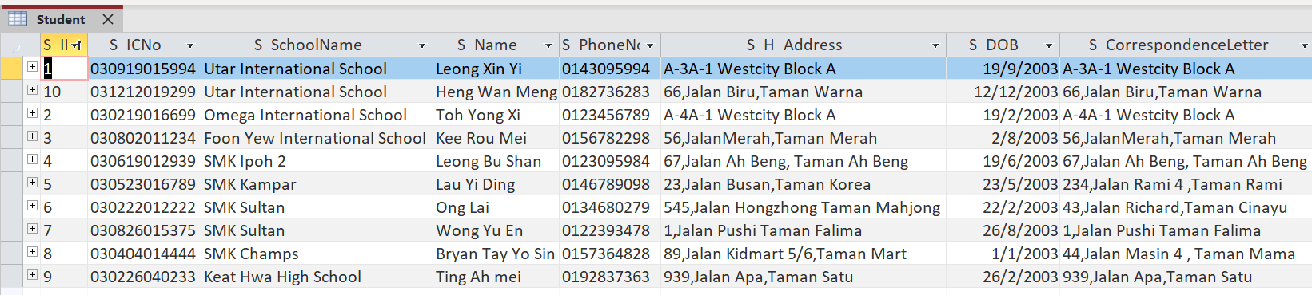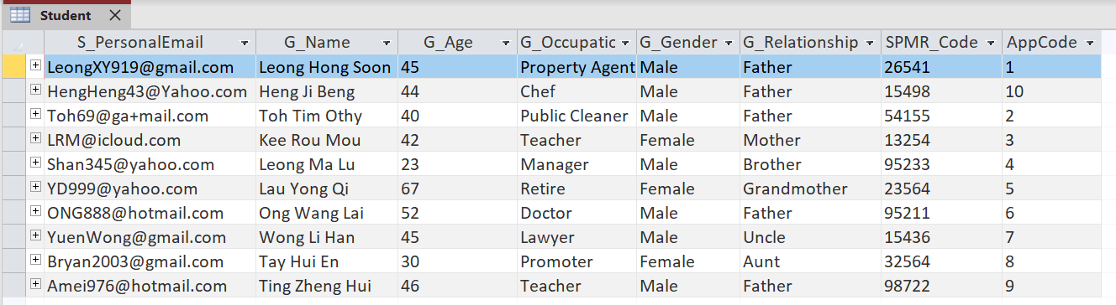

|  |
| --- |
| **Figure 1.3** |

**Table 2: SPM Result**

**Attributes:**

* **Data Dictionary**

|  |  |  |
| --- | --- | --- |
| Field Name | Data Type | Description |
| SPMR_Code | Short Text | References for student's SPM result |
| Malay | Short Text | Grade for Malay Language |
| Eng | Short Text | Grade for English Language |
| Math | Short Text | Grade for Mathematics |
| Add_Math | Short Text | Grade for Additional Mathematics |
| Sci | Short Text | Grade for Science |
| Phy | Short Text | Grade for Physics |
| Chem | Short Text | Grade for Chemistry |
| Bio | Short Text | Grade for Biology |
| Add_Sci | Short Text | Grade for Additional Science |
| His | Short Text | Grade for History |
| S_ID | Short Text | References for student details |

|  |
| --- |
| **Figure 1.4** |

* Data Record

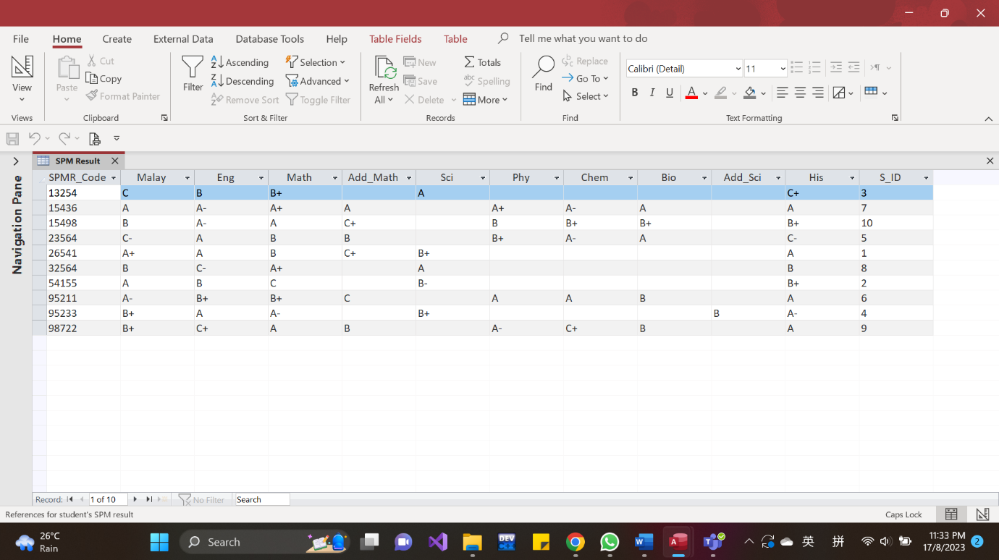

|  |
| --- |
| **Figure 1.5** |

**Table 3: Submission**

**Attributes:**

* **Data Dictionary**

|  |  |  |
| --- | --- | --- |
| Field Name | Data Type | Description |
| AppCode | Short Text | Reference of application |
| S_id | Short Text | Reference of student details |
| SubDate | Date | Submission date |

|  |
| --- |
| **Figure 1.6** |

* Data Record

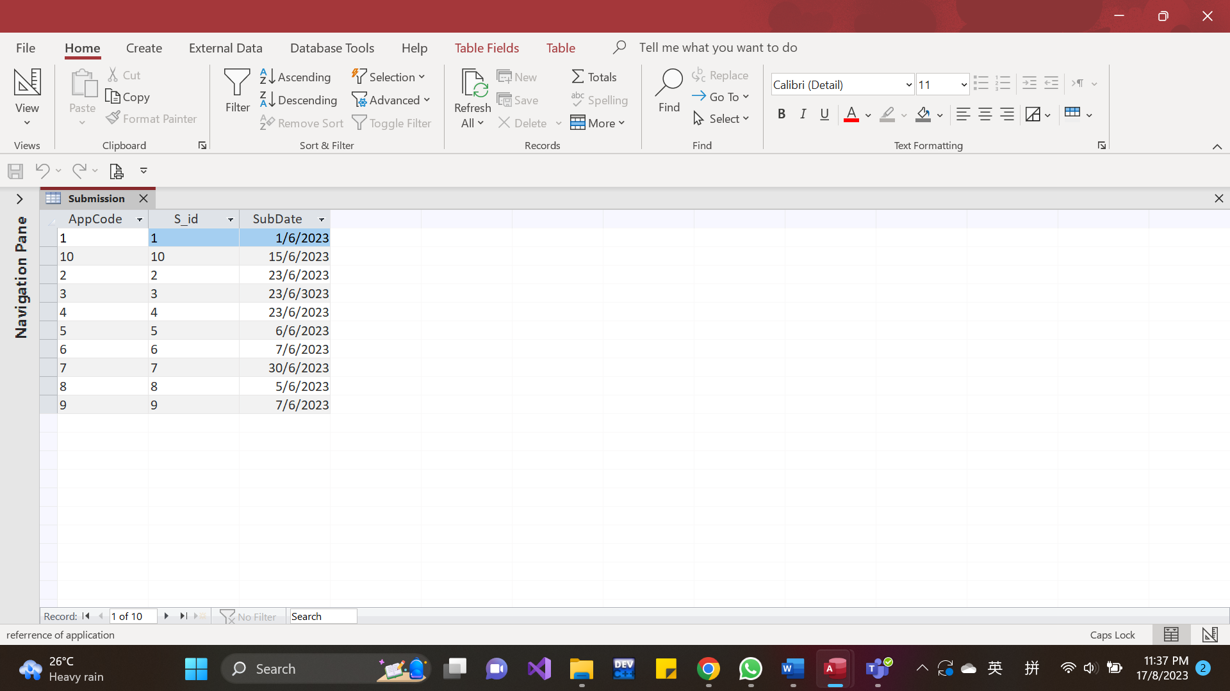

|  |
| --- |
| **Figure 1.7** |

**Table 4: Application**

**Attributes:**

* **Data Dictionary**

|  |  |  |
| --- | --- | --- |
| Field Name | Data Type | Description |
| AppCode | Short Text | References for the application |
| AppDate | Short Text | Date applied for the scholarship |
| Appextraactivity | Long Text | The extracurricular activities participated in by applicants |
| Appcomactivity | Long Text | The community activities participated in by applicants |
| AppStatus | Yes/No | Application status |
| RecommendCode | Short Text | Reference of recommendation |
| ScholarshipID | Short Text | Reference of the scholarship applied |
| Remark | Long Text | Remark for the status |

|  |
| --- |
| **Figure 1.8** |

* Data Record

|  |
| --- |
| **Figure 1.9** |

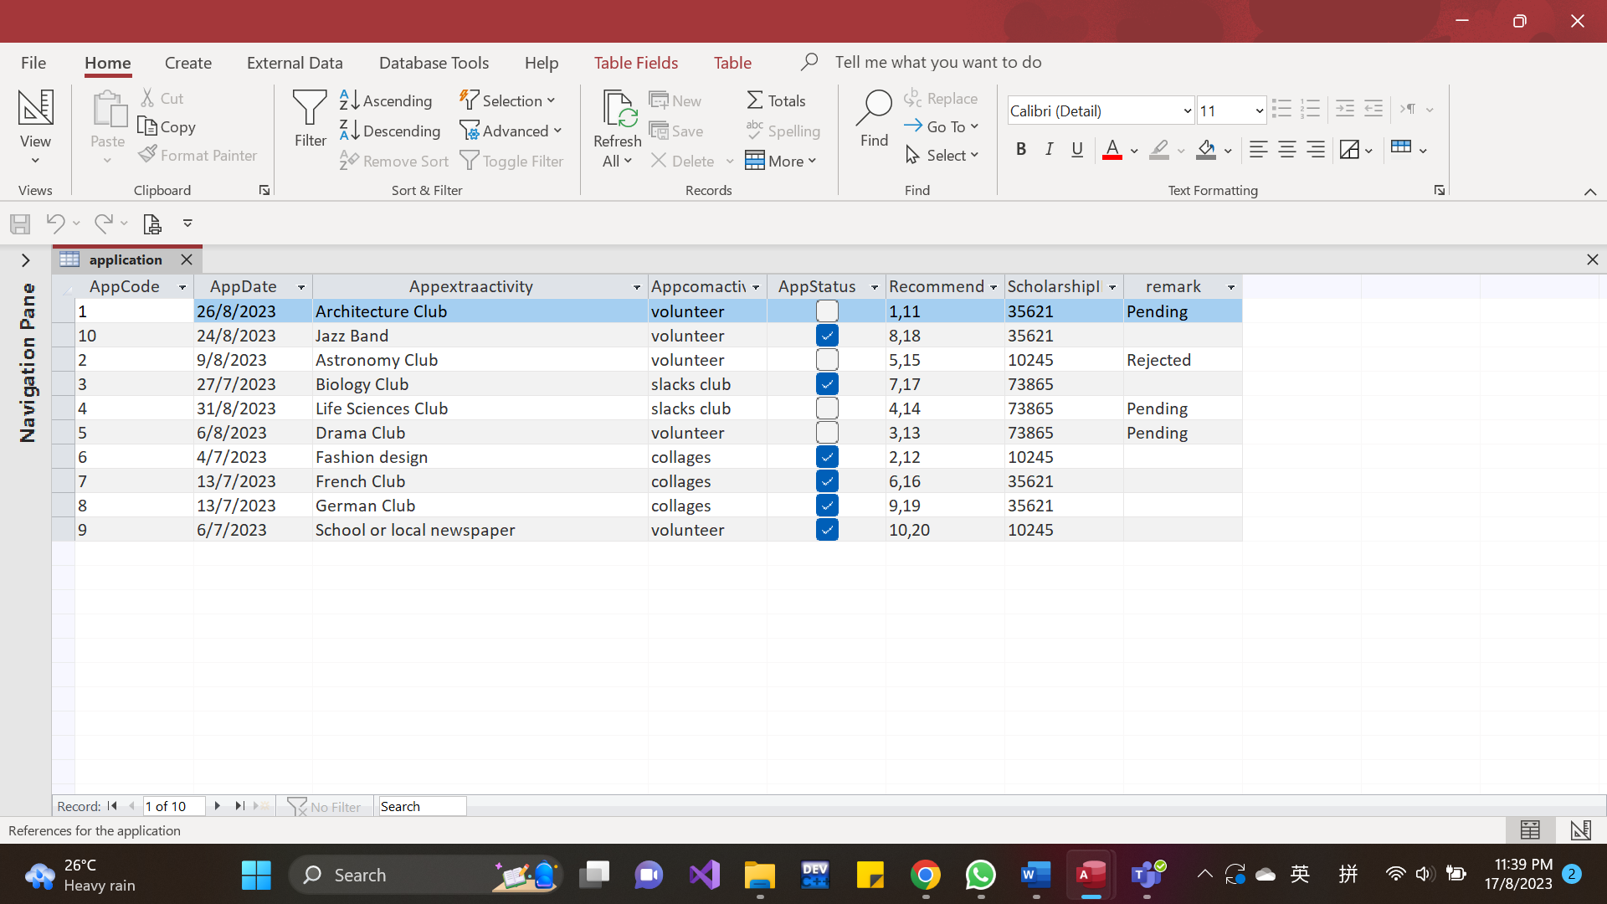

**Table 5: Recommendation**

**Attributes:**

* Data Stationary

|  |  |  |
| --- | --- | --- |
| Field Name | Data Type | Description |
| RecommendCode | Short Text | Reference of recommendation |
| refID | Short Text | Reference of referees |
| AppCode | Short Text | Reference of application |
| RecommendReason | Long Text | Reasons of recommending the applicant |

|  |
| --- |
| **Figure 2.0** |

**Table 6: Referee**

**Attributes:**

* **Data Dictionary**

|  |  |  |
| --- | --- | --- |
| Field Name | Data Type | Description |
| refID | Short Text | Reference of referees |
| refName | Short Text | referee's name |
| refRelationship | Short Text | relationship between Applicant and Referees |
| refOccupation | Short Text | Referee's occupation |
| refPhoneNo | Short Text | Referee's phone number |
| refAddress | Short Text | referee's address |
| RecommendCode | Short Text | references of recommendation |

|  |
| --- |
| **Figure 2.1** |

**Table 7: Scholarship provider**

**Attributes:**

* **Data Dictionary**

|  |  |  |
| --- | --- | --- |
| Field Name | Data Type | Description |
| ScholarshipID | Short Text | Reference for the Scholarship |
| ScholarshipName | Short Text | The Scholarship's Name |
| ProviderID | Short Text | Reference of the providers |
| ProviderName | Short Text | Name of the Scholarship Provider |
| ProviderOrganisation | Short Text | Organisation for the Scholarship Provider |

|  |
| --- |
| **Figure 2.2** |

|  |
| --- |
| **Figure 2.3** |

* Data Record

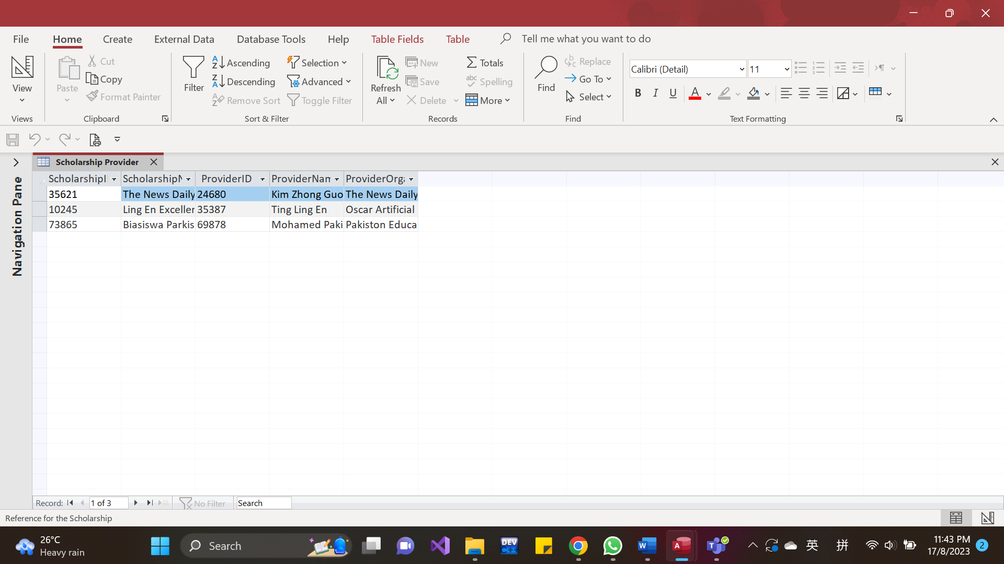

**3.2 Switchboard**

**Switchboard in Microsoft Access brings out the conveniences for users and let them get the data easily. The users are able to get the data with just a finger tips. Also, there will be more user-friendly if there is a button to entry into and exit from the objects.**

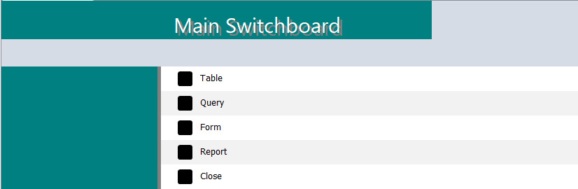

|  |
| --- |
| **Figure 2.4** |

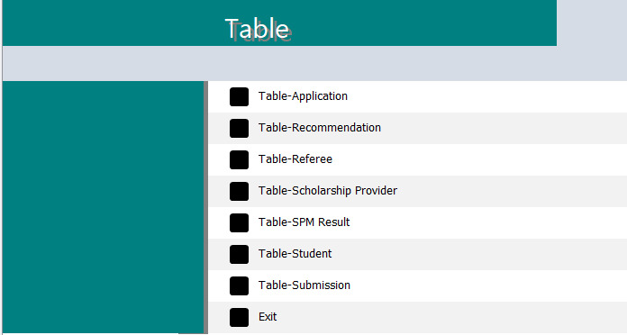

|  |
| --- |
| **Figure 2.5** |

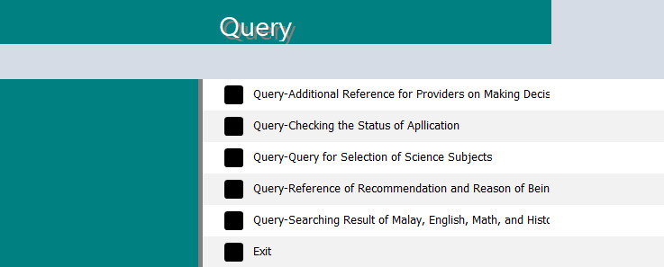

|  |
| --- |
| **Figure 2.6** |

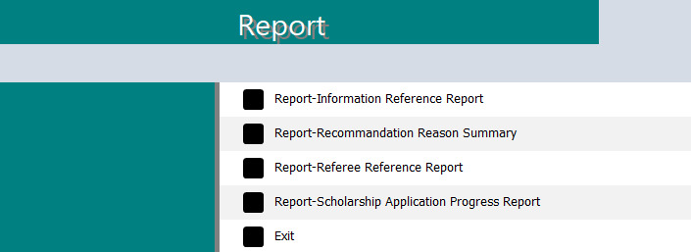

|  |
| --- |
| **Figure 2.7** |

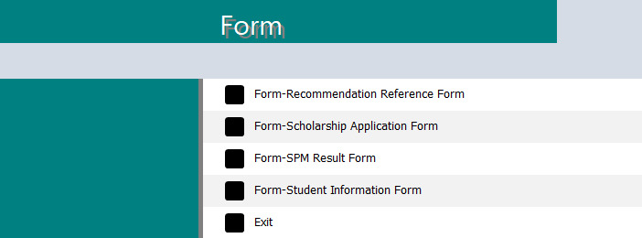

|  |
| --- |
| **Figure 2.8** |

**Chapter 4 : Database Objects**

* 1. **Queries**

**Query 1:** Searching the Result for Malay Language, English Language, Mathematics, and History

Explanation: To bring out the convenience on retrieve the result of four subjects

SQL Sequence:

SELECT Student.S_ID, Student.S_Name, [SPM Result].SPMR_Code, [SPM Result].Sci, [SPM Result].Phy, [SPM Result].Chem, [SPM Result].Bio, [SPM Result].Add_Sci

FROM [SPM Result] INNER JOIN Student ON [SPM Result].S_ID = Student.S_ID

GROUP BY Student.S_ID, Student.S_Name, [SPM Result].SPMR_Code, [SPM Result].Sci, [SPM Result].Phy, [SPM Result].Chem, [SPM Result].Bio, [SPM Result].Add_Sci;

**Result:**

|  |
| --- |
| **Figure 2.9** |

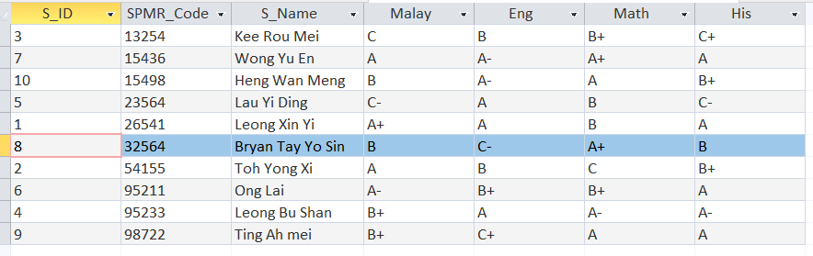

**Query 2:** Selection for the Science subjects

Explanation: To be easier on comparing the results before making the selections.

SQL Statement:

SELECT Student.S_ID, Student.S_Name, [SPM Result].SPMR_Code, [SPM Result].Sci, [SPM Result].Phy, [SPM Result].Chem, [SPM Result].Bio, [SPM Result].Add_Sci

FROM [SPM Result] INNER JOIN Student ON [SPM Result].S_ID = Student.S_ID

GROUP BY Student.S_ID, Student.S_Name, [SPM Result].SPMR_Code, [SPM Result].Sci, [SPM Result].Phy, [SPM Result].Chem, [SPM Result].Bio, [SPM Result].Add_Sci;

**Result:**

|  |
| --- |
| **Figure 3.0** |

**Query 3:** Checking the status of the application progress

Explanation: To help the user so that they are able to track and update the progress in no time.

SQL Statement:

SELECT Submission.SubDate, application.AppCode, Student.S_ID, application.AppDate, application.AppStatus, application.ScholarshipID, application.remark

FROM Student INNER JOIN (application INNER JOIN Submission ON application.AppCode = Submission.AppCode) ON Student.S_ID = Submission.S_id;

**

|  |
| --- |
| Figure 3.1 |

**Query 4:**  Reference of the recommendation and reasons for being recommended

Explanation: To have the references easily and the providers able to make their decisions easily.

SQL Statement:

SELECT Recommendation.AppCode, Recommendation.refID, Recommendation.RecommendReason, referee.refName, referee.refRelationship

FROM (Recommendation INNER JOIN referee ON Recommendation.refID = referee.refID) INNER JOIN application ON Recommandation.AppCode = application.AppCode

ORDER BY referee.refName;

**Result:**

|  |
| --- |
| Figure 3.2 |

**Query 5:** Additional Reference for the scholarship application

Explanation: Providers are able to refer these records easily if they can’t make the decisions

SQL Statement:

SELECT Student.S_ID, Student.S_Name, application_1.AppCode, application_1.Appextraactivity, application_1.Appcomactivity

FROM application, application AS application_1 INNER JOIN Student ON application_1.AppCode = Student.AppCode

GROUP BY Student.S_ID, Student.S_Name, application_1.AppCode, application_1.Appextraactivity, application_1.Appcomactivity;

**Result:**

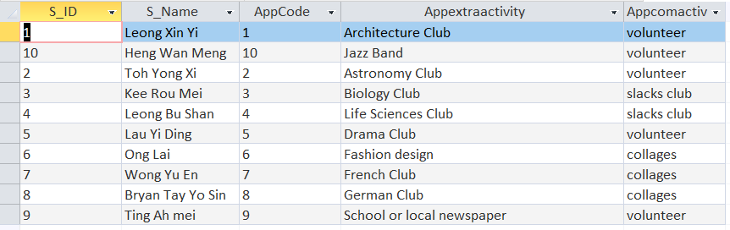

|  |
| --- |
| Figure 3.3 |

**4.2 Forms**

Forms are used to display, enter, and change data in an useful window. Word forms can also be used to display the contents of related tables.

**4.2.1 Students Information Forms**

Explanation:

You can look up the students information including students’ guardians information in this forms.

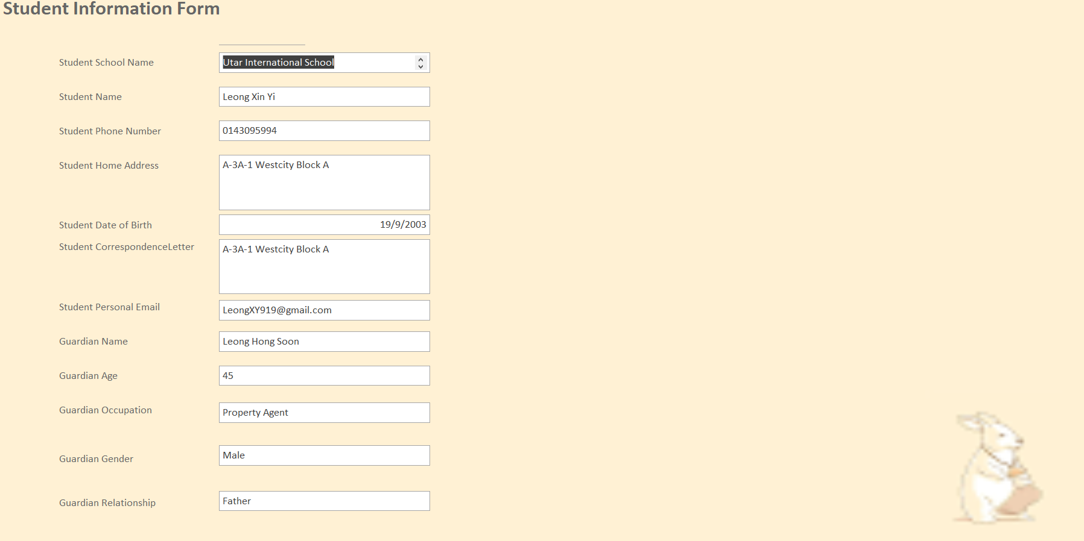Sample Students Information Forms:

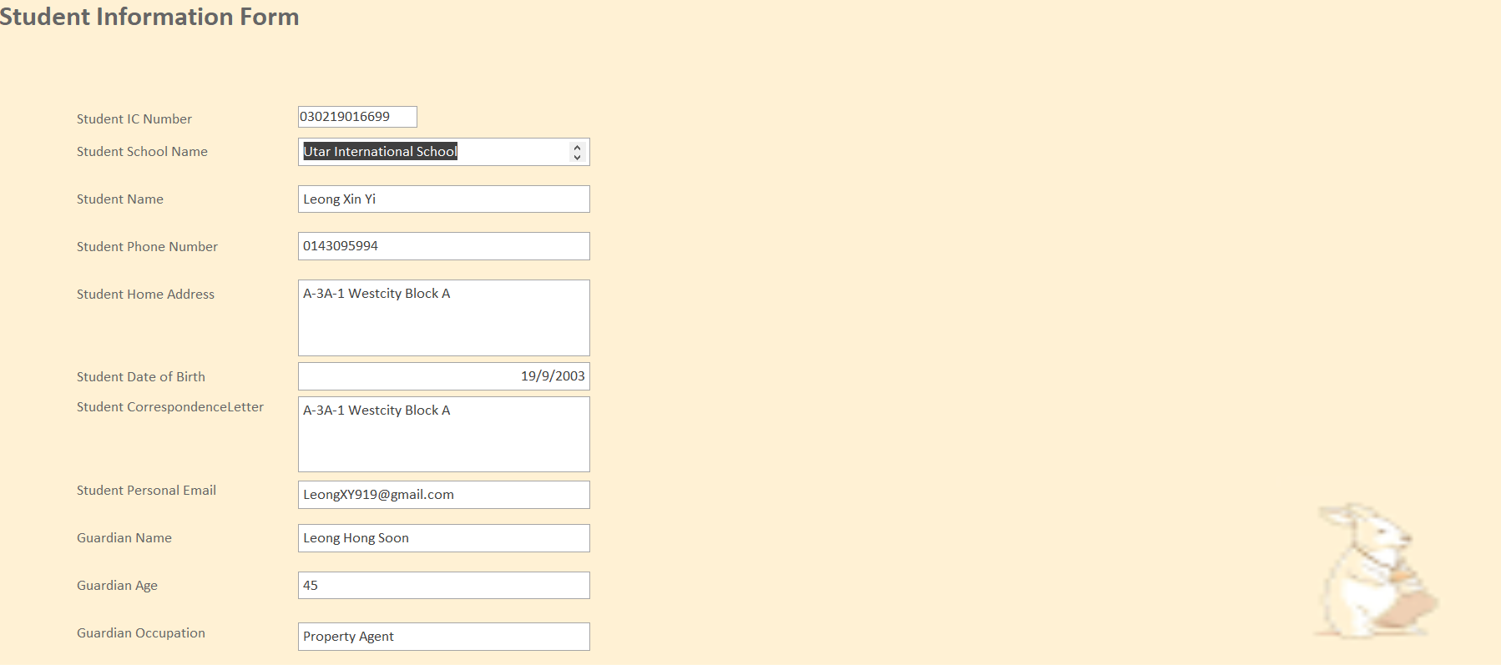

|  |
| --- |
| Figure 2.9 |

|  |
| --- |
| **Figure 3.4** |

**4.2.2 SPM Results**

Explanation:

Through this forms, you can insert your result on each subject so that the provider can have a review on your result.

Sample SPM Results:

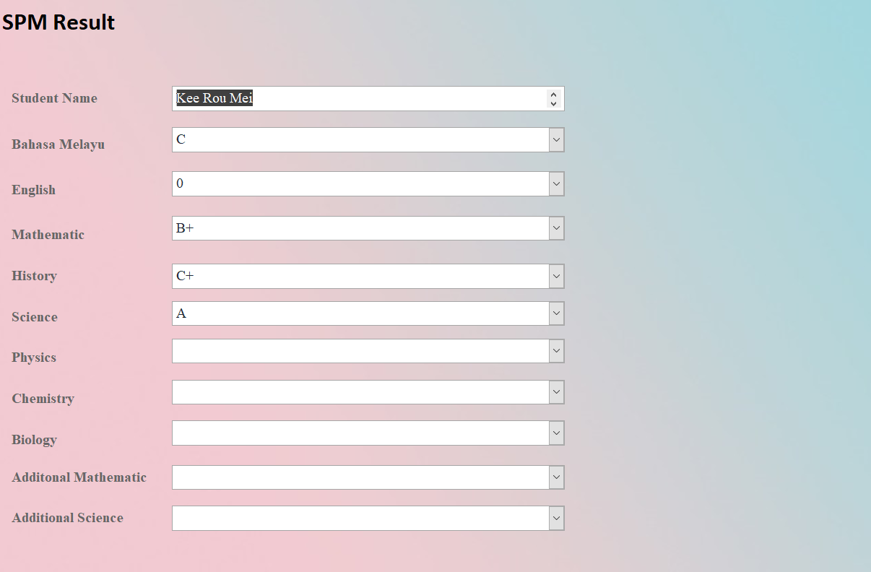

|  |
| --- |
| **Figure 3.5** |

**4.2.3 Scholarship Provider**

Explanation:

This form can let the scholarship provider to know that which scholarship that students apply and active in some activities.

Sample Scholarship Provider:

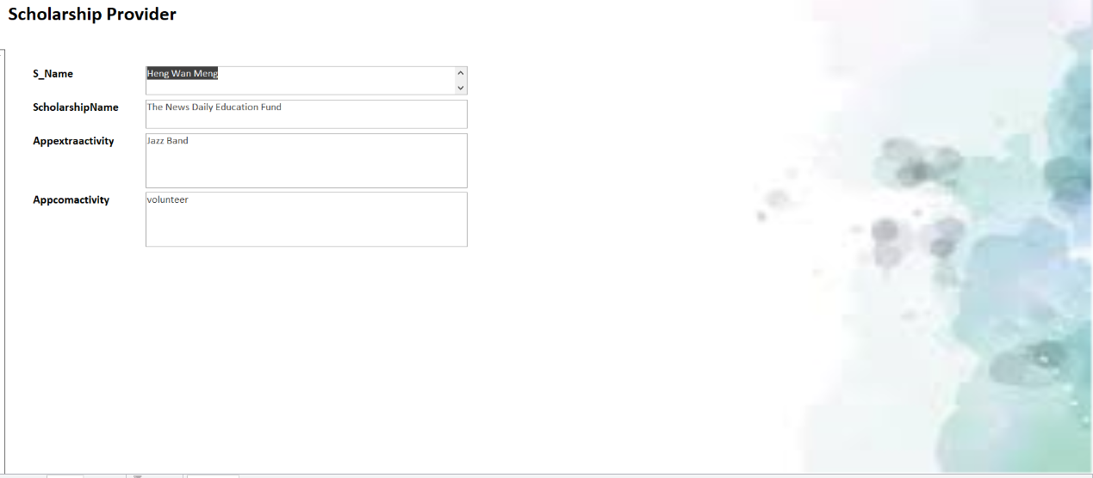

|  |
| --- |
| **Figure 3.6** |

**4.2.4 Recommendation Reference**

Explanation:

Provider can know that the referee why they recommend this student with clearly reason.

Sample Recommendation Reference:

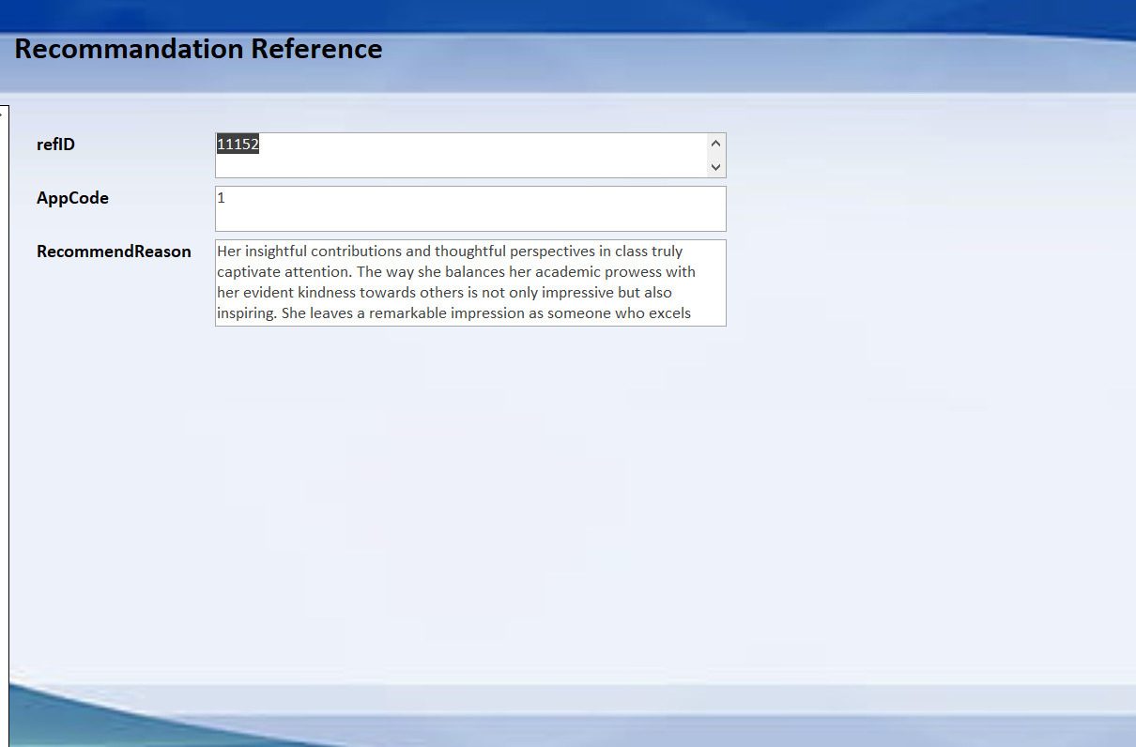

|  |
| --- |
| **Figure 3.7** |

**4.3 Reports**

Reports contain useful data for decision-making and analysis and are utilised for the formatted results of database searches.

The report's job is to sort and summarise the data in the database, which is then displayed in hard and soft copy for analysis. This is basically a front-end interface for calling or running back-end database queries that have been structured for convenient application use.

**4.3.1 Information Reference Reports**

Explanation: To review more students information, including SPM Code, Subjects, Extra activity and Community.

Sample Information Reference Report:

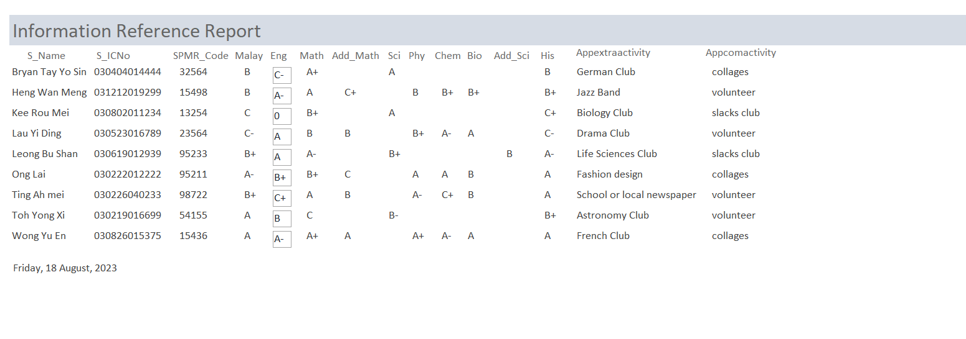

|  |
| --- |
| **Figure 3.8** |

**4.3.2 Referee Reference Reports**

Explanation: To review referee information.

Sample Referee Reference Reports:

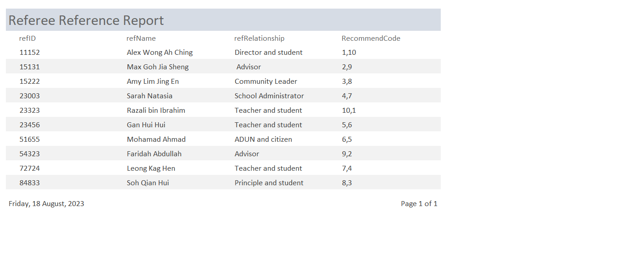

|  |
| --- |
| **Figure 3.9** |

**4.3.3 Scholarship Application Progress Reports**

Explanation: To track the status of scholarship application.

Sample Scholarship Application Progress Reports:

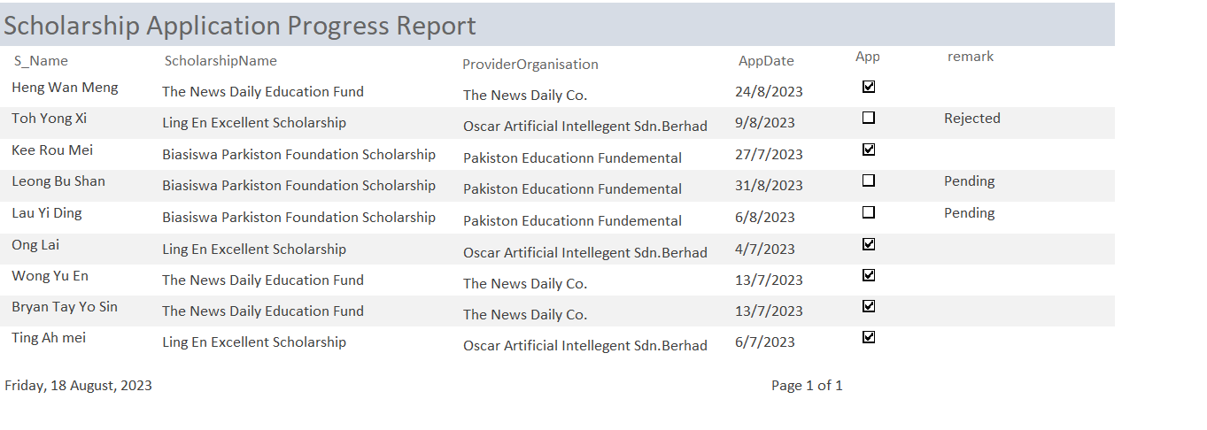

|  |
| --- |
| Figure 4.0 |

**4.3.4 Recommendation Reason Summary**

Explanation: To outline the recommendations.

Sample Recommendation Reason Summary: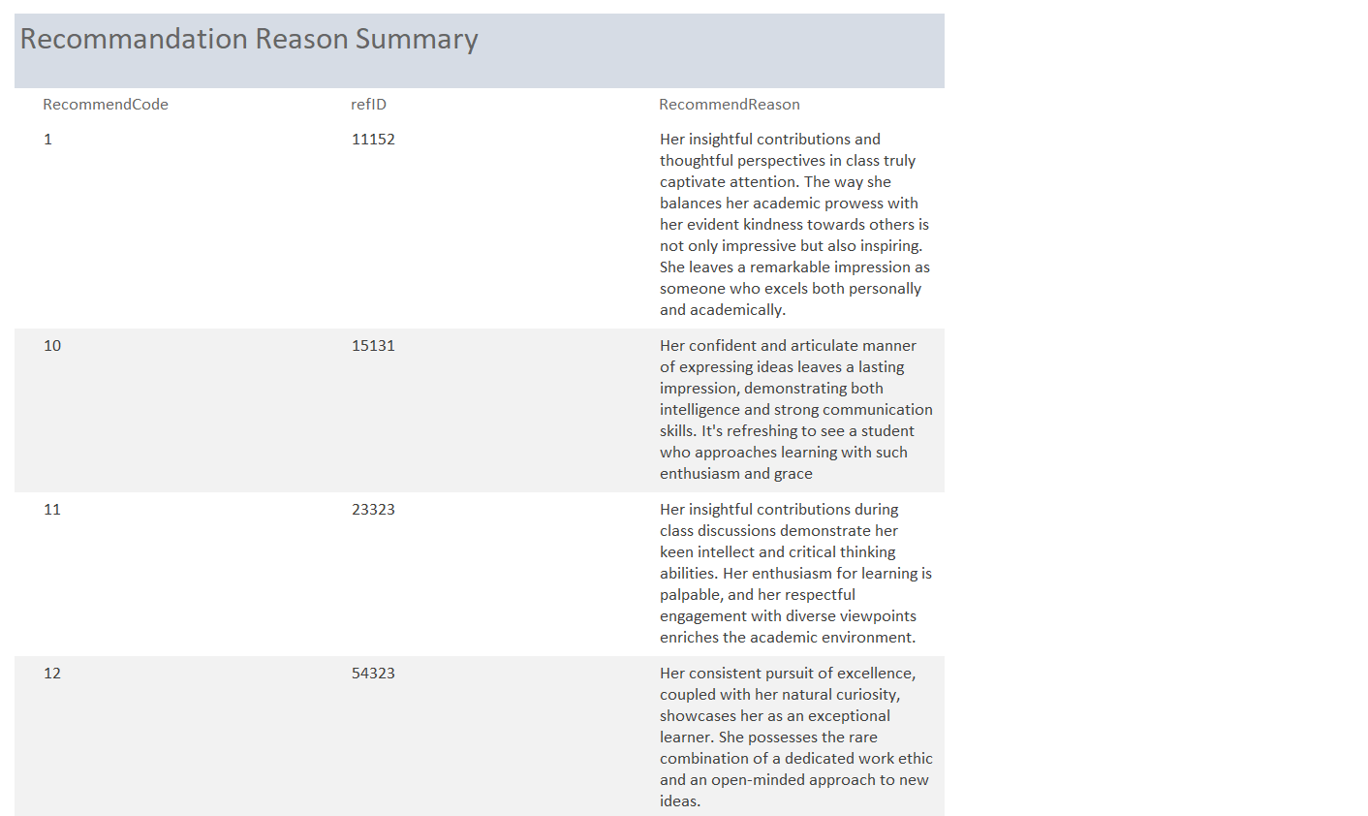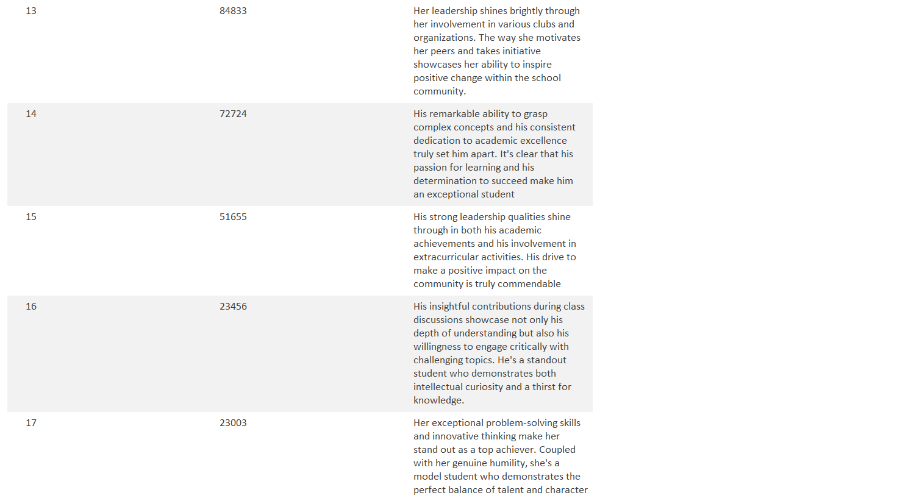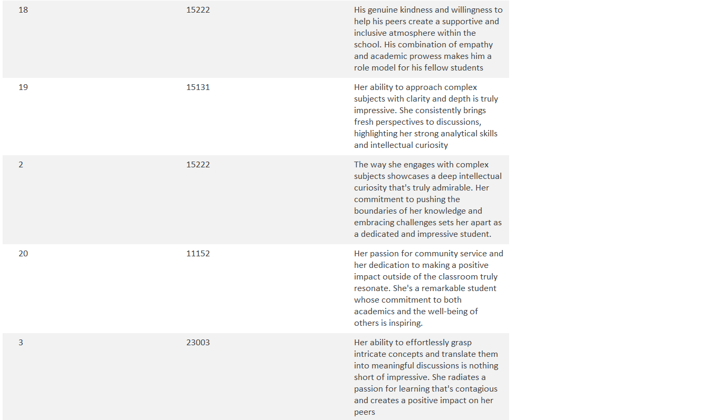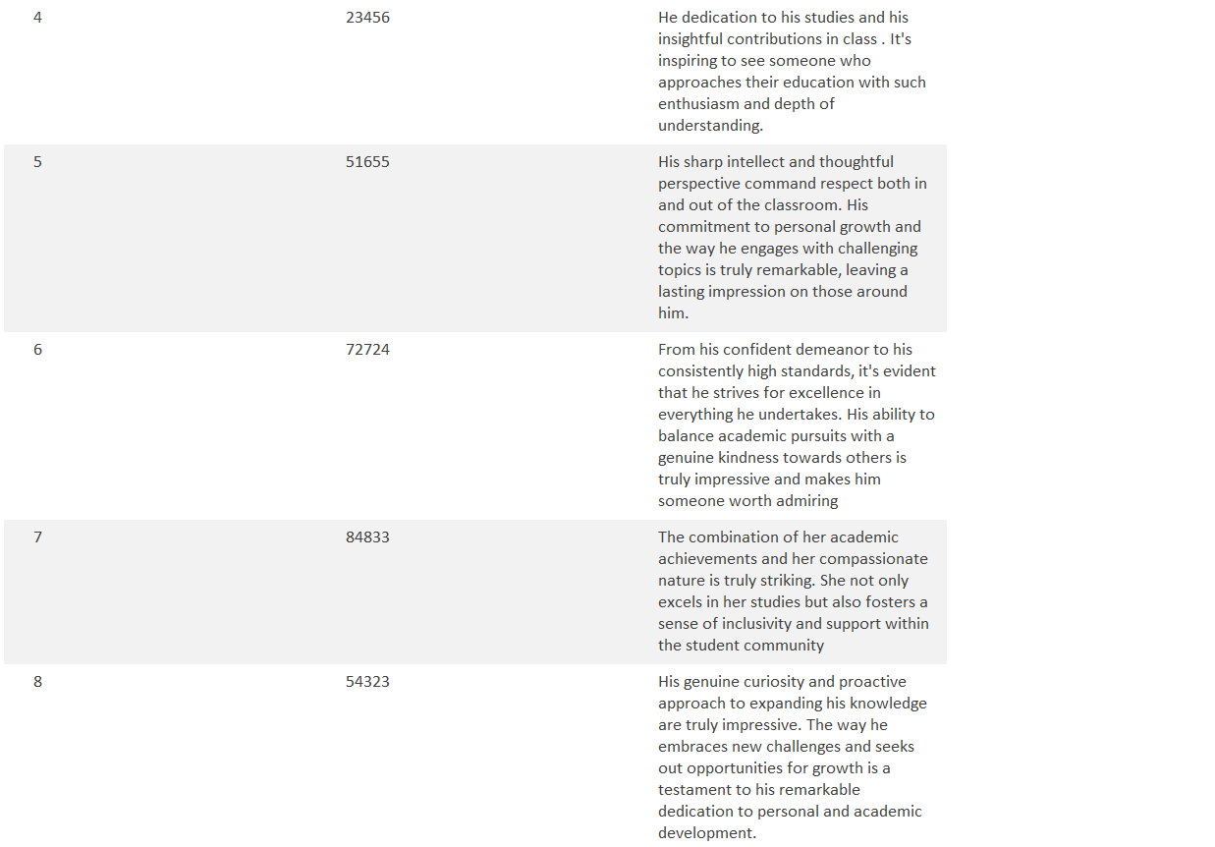

|  |
| --- |
| **Figure 4.1** |

**Chapter 5 : Conclusion**

In the conclusion, we have studied about the scholarship application case and managed to build up the database for the entire case. There is some weakness for the database although we have built up the database successfully and there will be many room of improvement.

* 1. **System Weakness**

There are some weakness for our database:

1. Not present the relationship accurately
2. Over-normalisation
3. Weak in documentary and training
   1. **Future Improvement**

There are some improvements that we need to have in the future:

1. The accuracy of the connection between all of the table:

We have to ensure that the relationship between the tables especially in the database is similar and exactly same with the concept that has been discussed and the ERD.

1. Having the improvement on exception of some wrong or not reasonable and logical:

We must have a check and analyse the example record or data before key in in the database to ensure they are able to become a reasonable or logical record in the reality.

1. Improvement of skills and ability of building up the database and the management system:

We are acknowledge that we are not having a good performance in this project due to lack of skills, ability and experience. hence, We have to enhance our skills and abilities on building up the database and management system and getting the experiences from having the practices so that we are able to build it up easily.